|  |  |
| --- | --- |
| Name Of The Student | SAHIL SENGRA |
| Internship Project Topic | WEBPAGE UI DESIGN |
| Name of the Organization | TCS-ION |
| Name of the Industry Mentor | Atul Devrukhka, Anushree_deshpande ( Administrator ) |
| Name of the Institute | PREPINSTA |

|  |  |  |
| --- | --- | --- |
| Date | Day # | Hours Spent |
| 27-12-2022 | 4 | 4.5HR |
| Activities done during the day:   1. Went through the links given in the project reference material, and tried to connect it with the project objective. 2. Making of Home Page.   My assignment is given below. | | |

Home Page : - Given Below

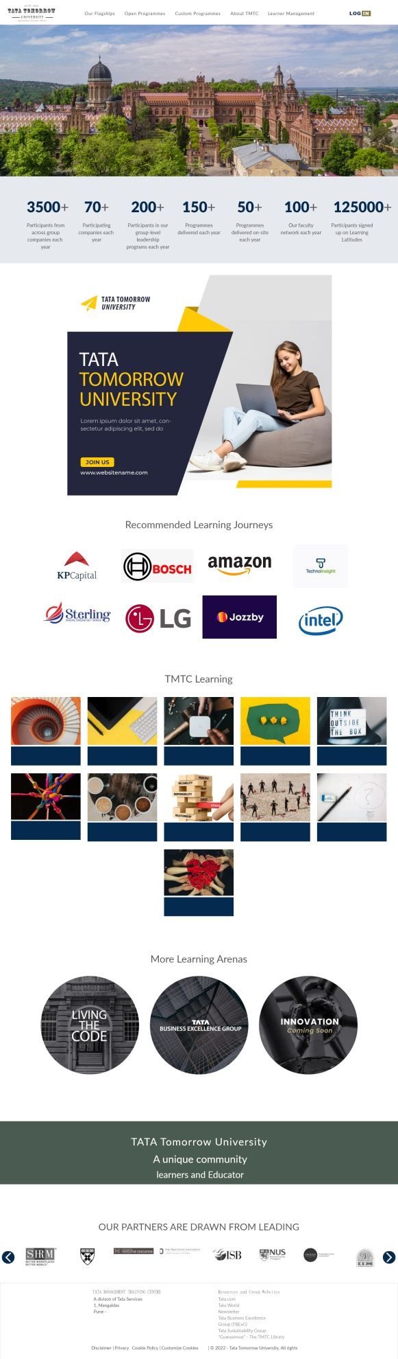

CLICK THIS ICON : THIS IS THE LOGO  
  
 

HERE THE PNG FILE OF MY FRAME WORK

